MACH4METAL

metalworking machinery
Transito 21
6909 DA BABBERICH Netherlands
Tel. +31 (0)316-247123
Fax: +31 (0)316-247956
info@mach4metal.com
www.mach4metal.com

Bank No : 66.52.13.883
IBAN : NL33 INGB 0665 2138 83
BIC : INGBNL2A

ECKOLD KF 665 Kraftformer

- Make : Walter ECKOLD Germany
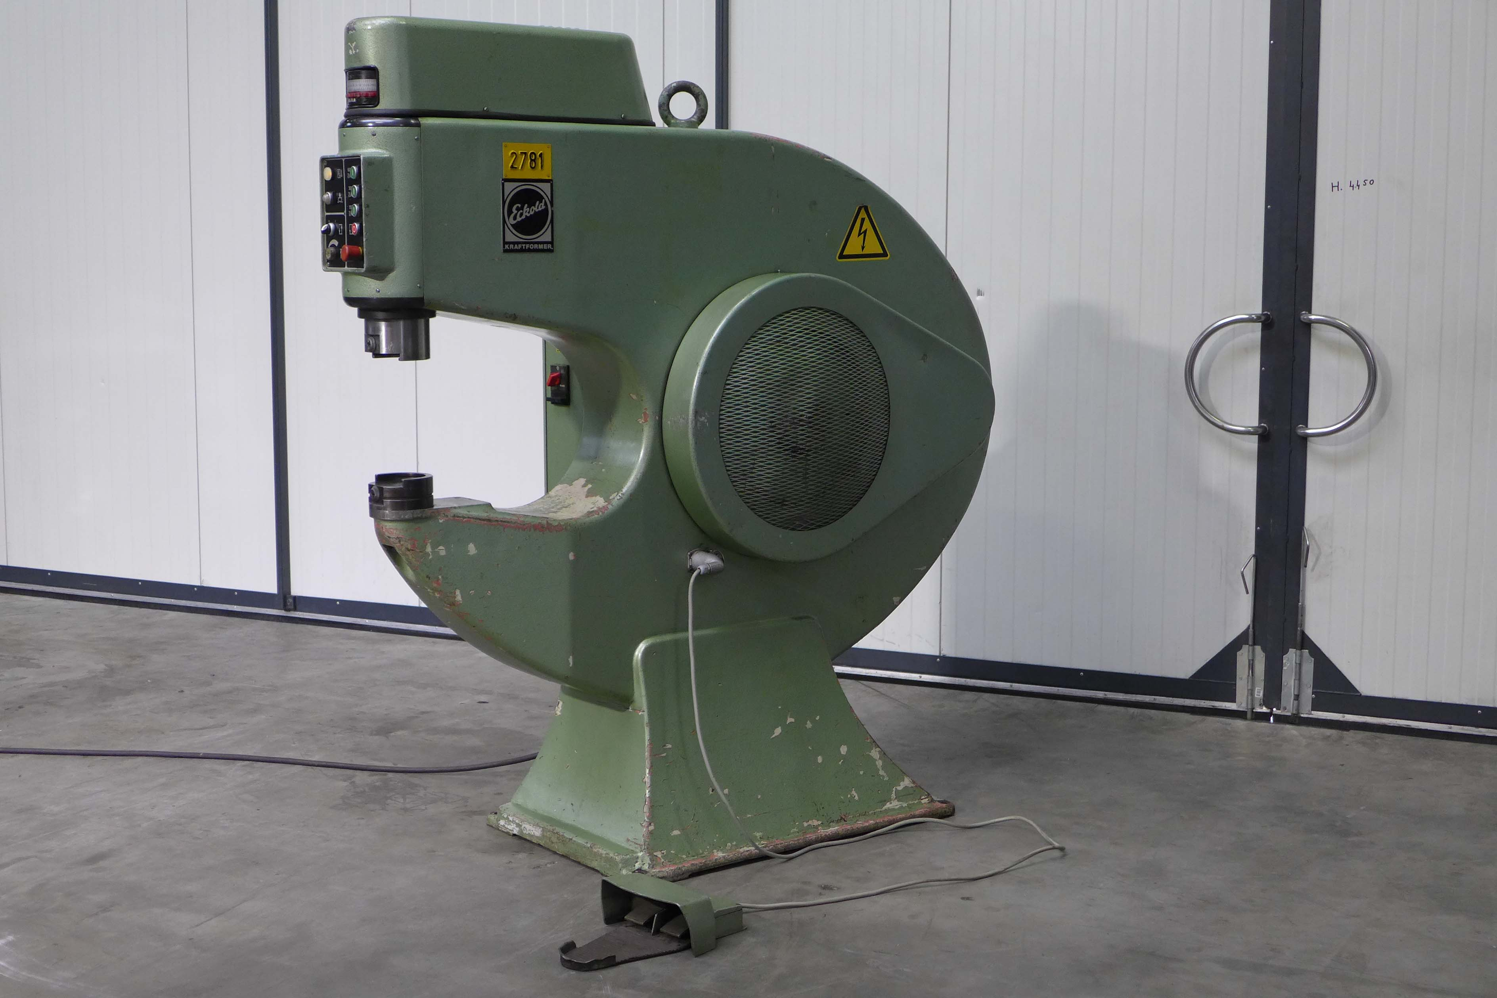
- Typ : KF 665
- Serial :
- YOP : 01 / 1992

- Horizontal Throat : 675
- Vertical Throat : 455

- Ram adjustment : 80
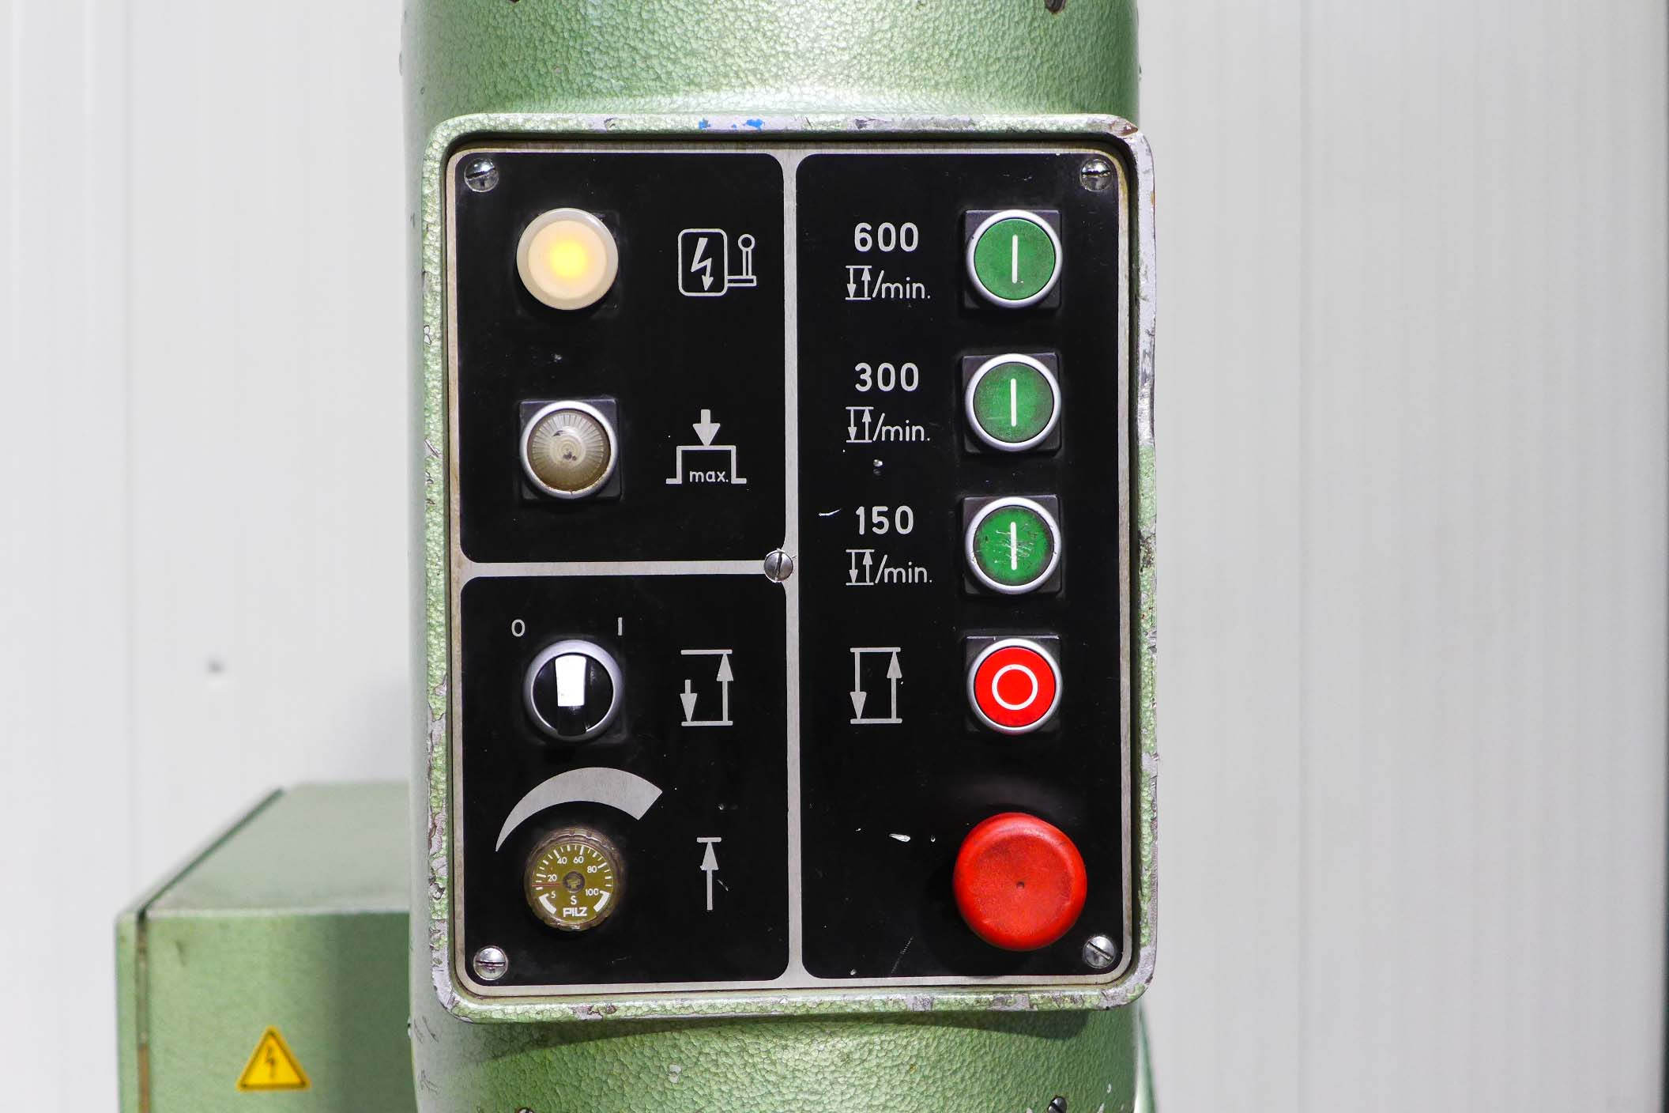
- Working stroke : 8
- Working strokes Rpm : 150 / 300 / 600

- Forming capacity:
- Mild steel 400 N/mm² : 6.0
- Aluminium 250 N/mm² : 8.0
- Stainless 600 N/mm² : 4.0

- Dimensions
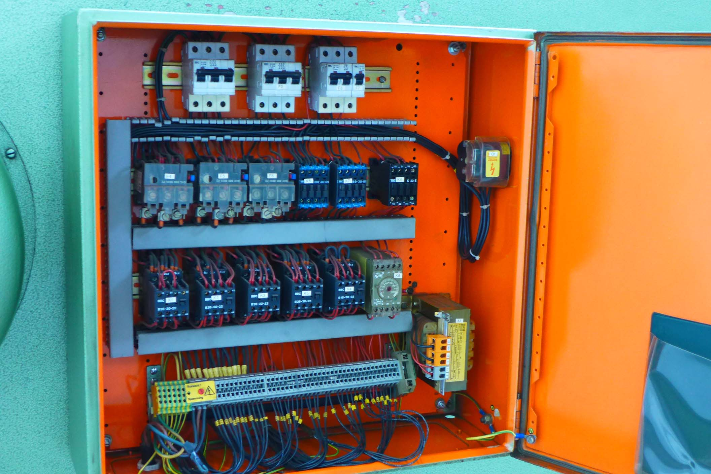
- Length : 1.950
- Width : 860
- Height : 2.050
- Weight : 2.000
- Power : 400 V / 4.5 kW

- Model with Potentiometer; limits reverse
motion time
- Foot switch for motorised adjustment ram
- 1 machine for Shrinking, Stretching,
Doming, Planishing, Reforming, Flattening, Straightening

Please Note: The above information has been obtained to the best of our ability and belief from, and from the manufacturers where possible. It is given in good faith, but its accuracy can not be guaranteed. Accordingly, it will not form a representation or constitute contractual terms. We advise you to check any vital details!

